**Digital Forensics Lab Report: 3**

Date: 10-08-2022

| Name: | Vedant H. Patel |
| --- | --- |
| Roll No: | 19BCP138 |
| Subject Code: | 20CP411P |
| Subject Name: | Digital Forensics Lab |

**Aim/Purpose:** Blogs, forums, and file uploader using the TOR browser.

**Tool Names:** TOR Browser

1. **Blogs / Essays / News Sites**

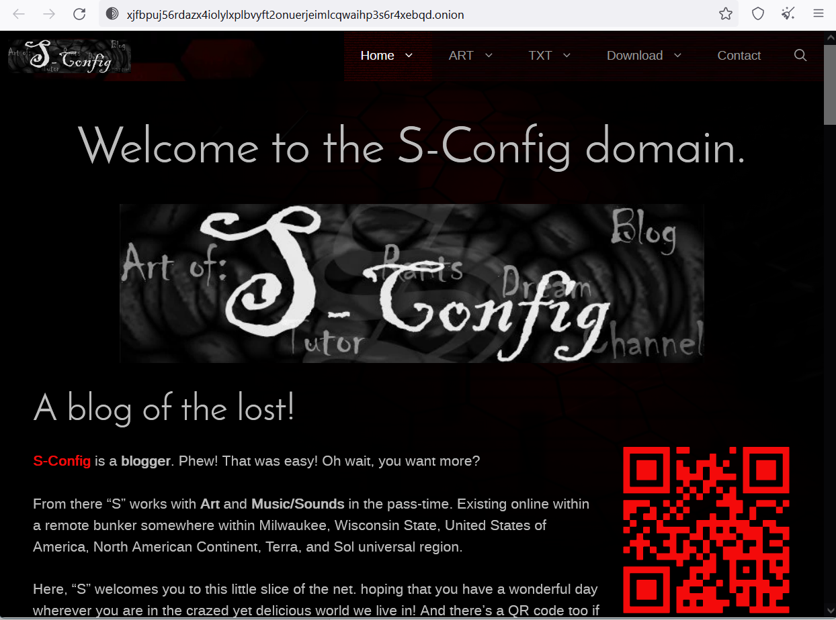

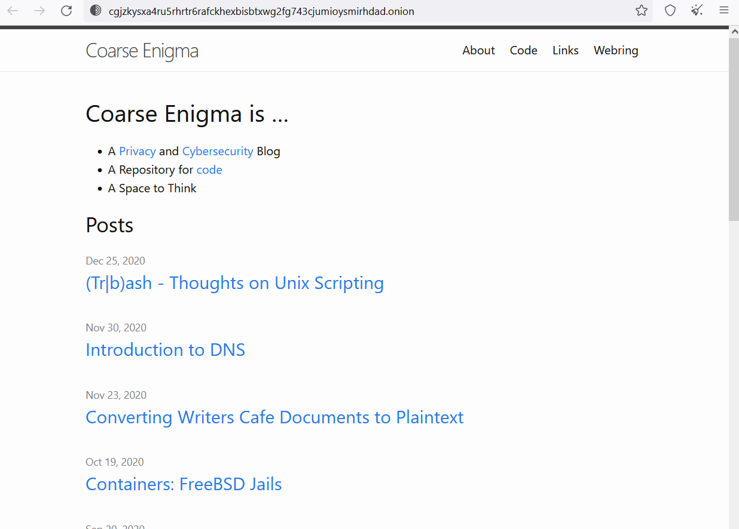



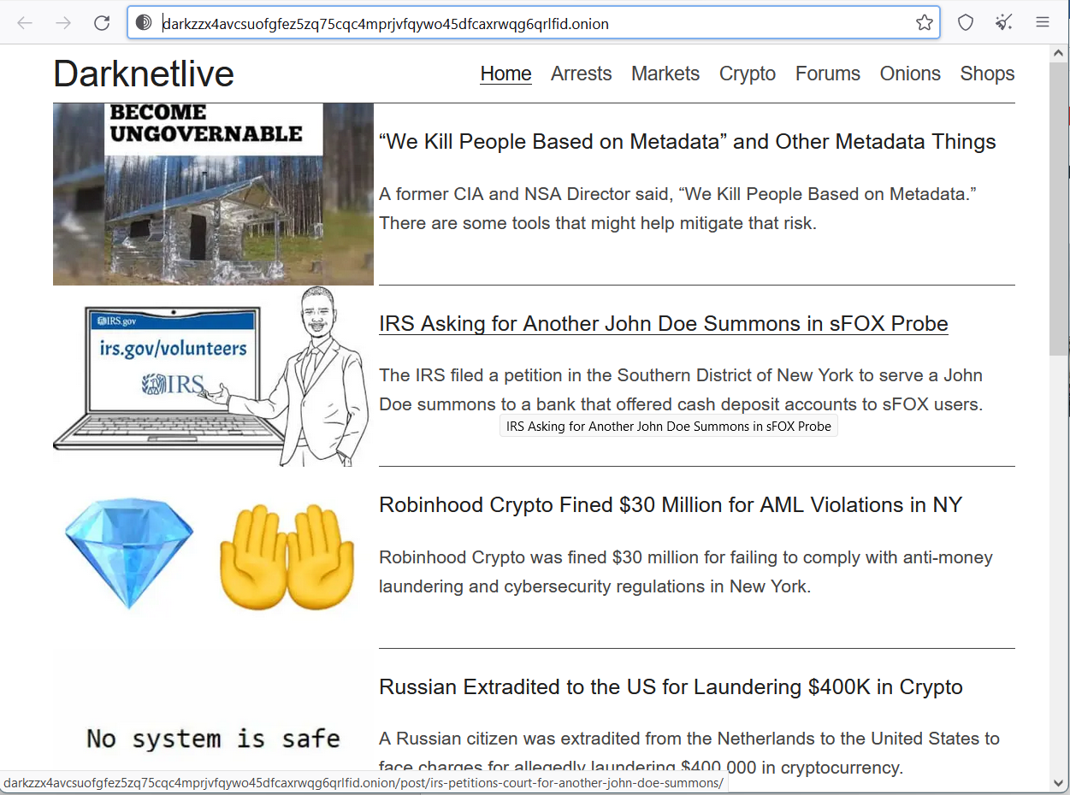

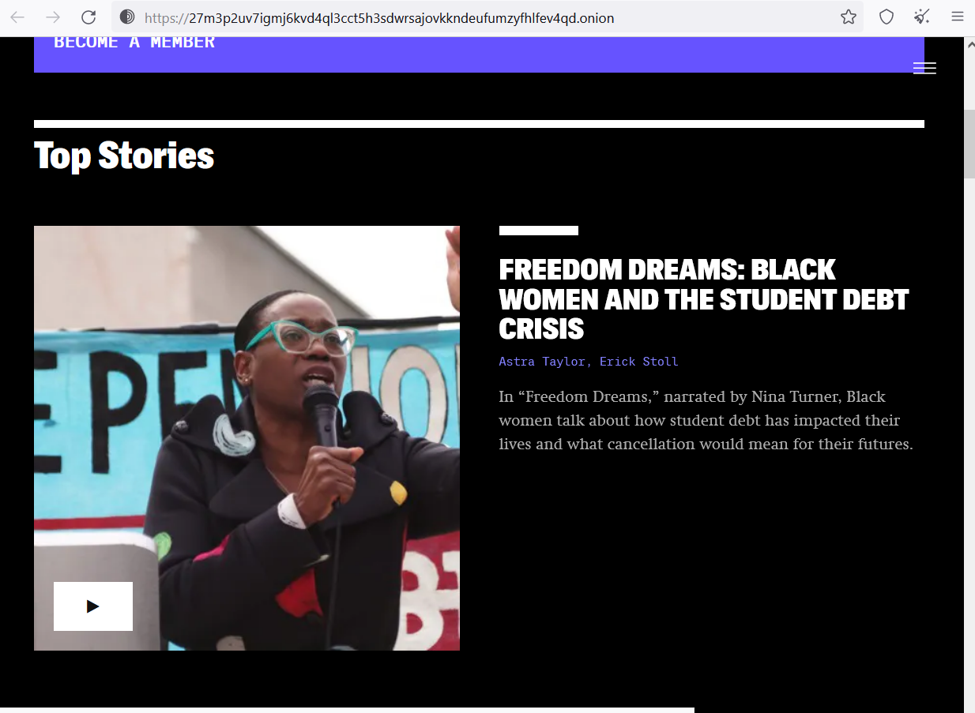

## Forums / Boards / Chats

## 

## 

## 

## 

## 

## File Uploader

## 

## 

## 

## 